**Assignment -1**

Digital Marketing

|  |  |
| --- | --- |
| Student Name | Kali Sangareshwari M |
| Student Roll Number | 20URCS019 |
| NM ID | 2CACCF0CD5ECD7581324C8C06D826450 |
| College Name | AAA College of Engineering and Technology |

**QUESTION:**

**Create a blog or website using Blogspot and WordPress. Customize the theme design and post new article with 500 words.**

**BLOG USING BLOGSPOT:**

**Blog link:** <https://royalwrists800.blogspot.com/2023/08/in-world-where-technology-is-constantly.html>

**Blog Title: Royal Wrists**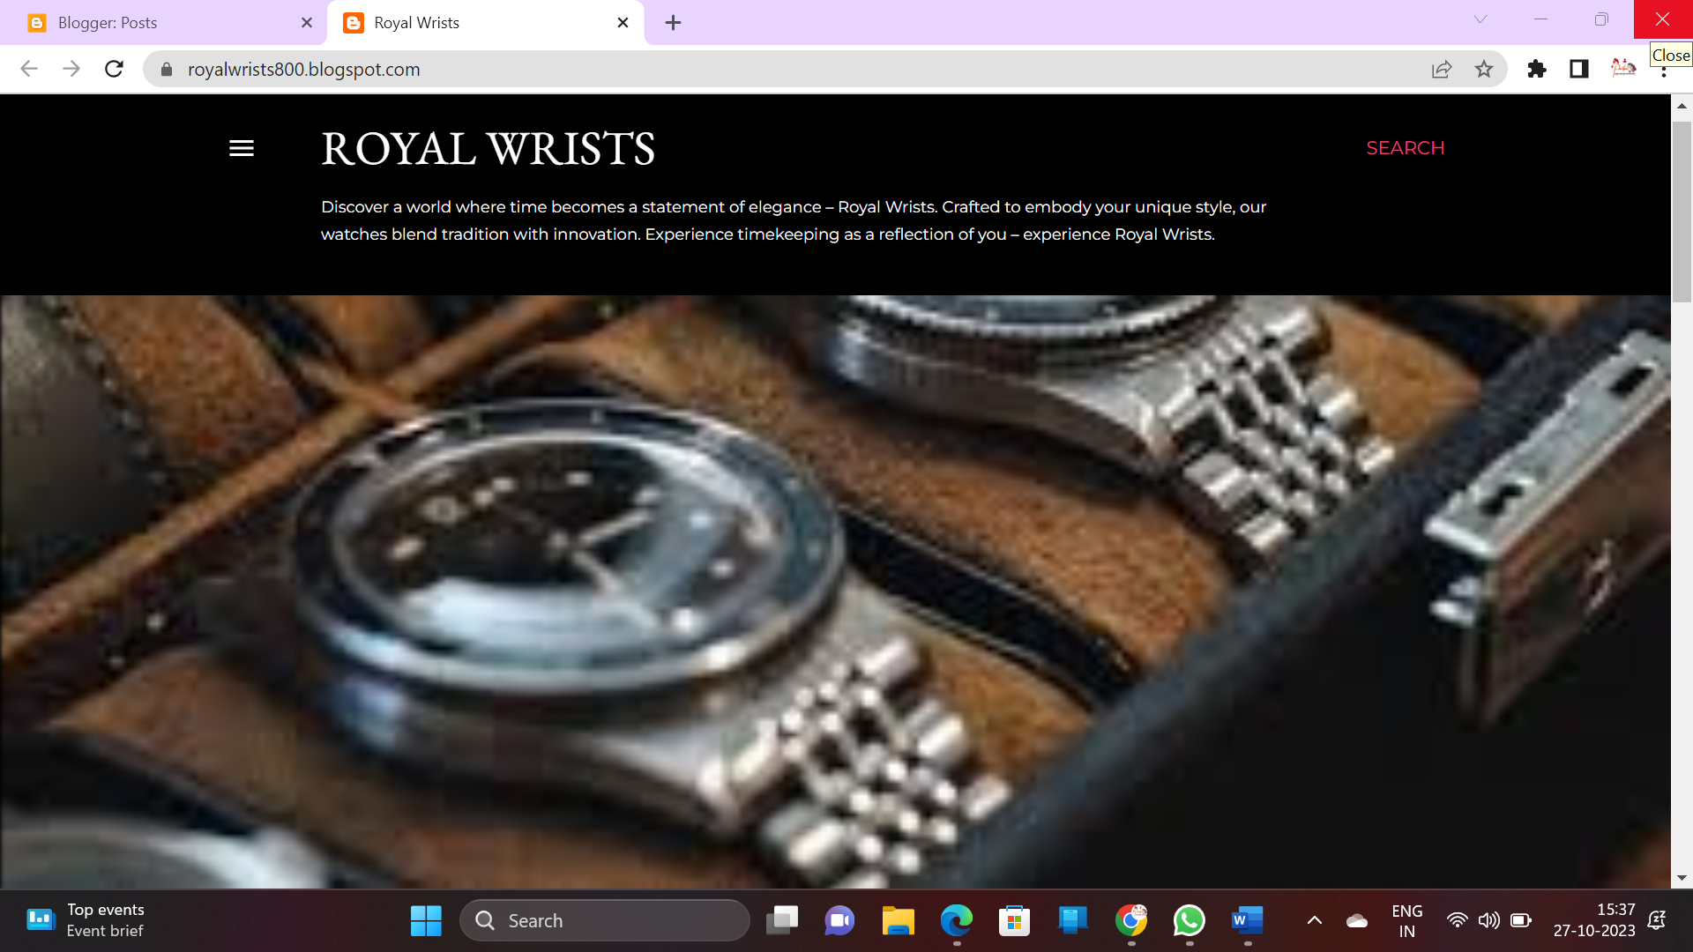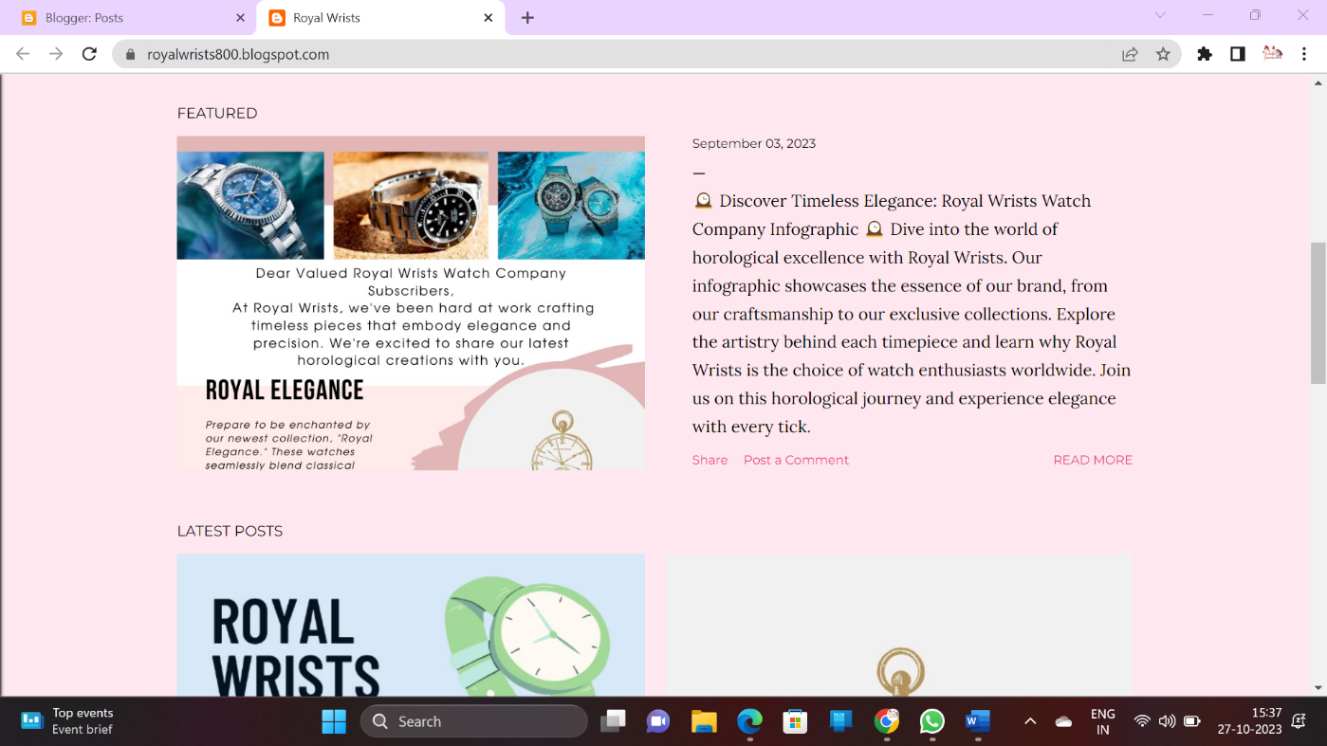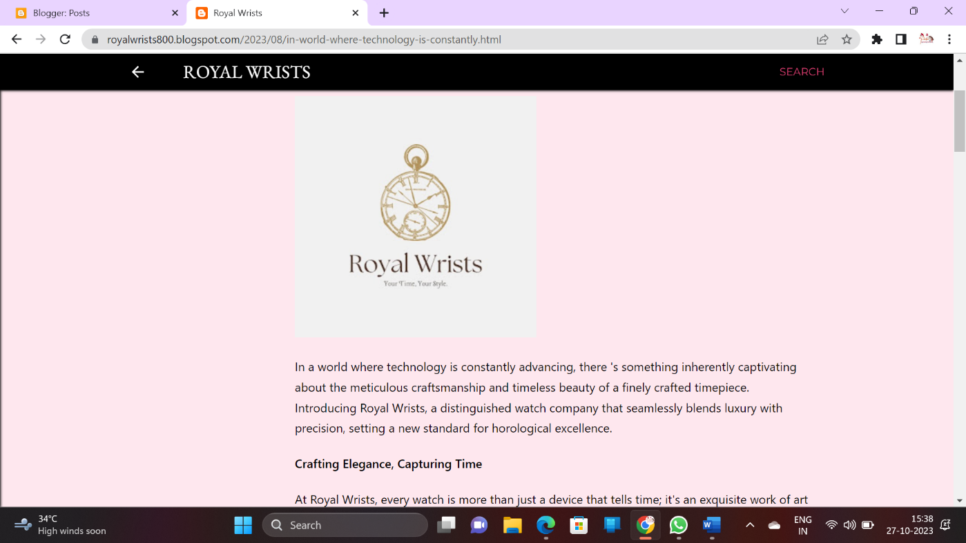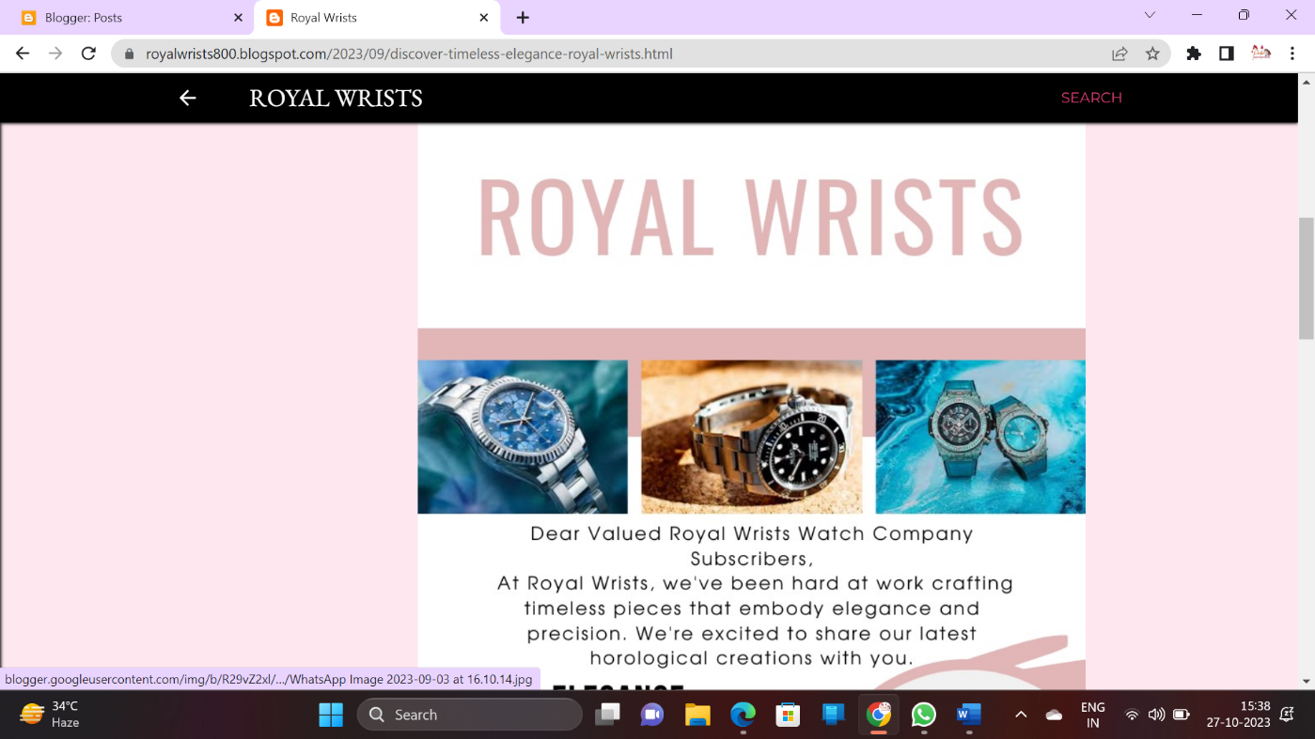

**BLOG USING WORDPRESS:**

**Wordpress link:** <https://kaliwp.augusta2k23.in/>

**Blog Title: Royal Wrists**

